**HTML Lab Assignments**

**Q1) Text Formatting**

Design a HTML page like the image below.

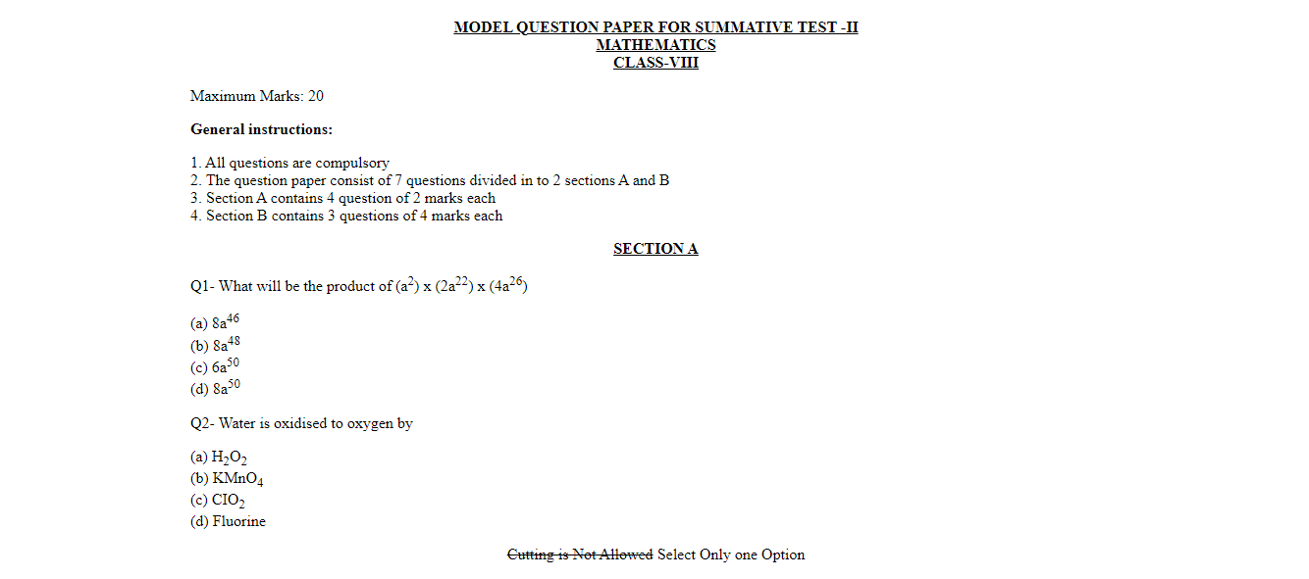

**Q2) Working with lists**

Design a HTML page like the image below.

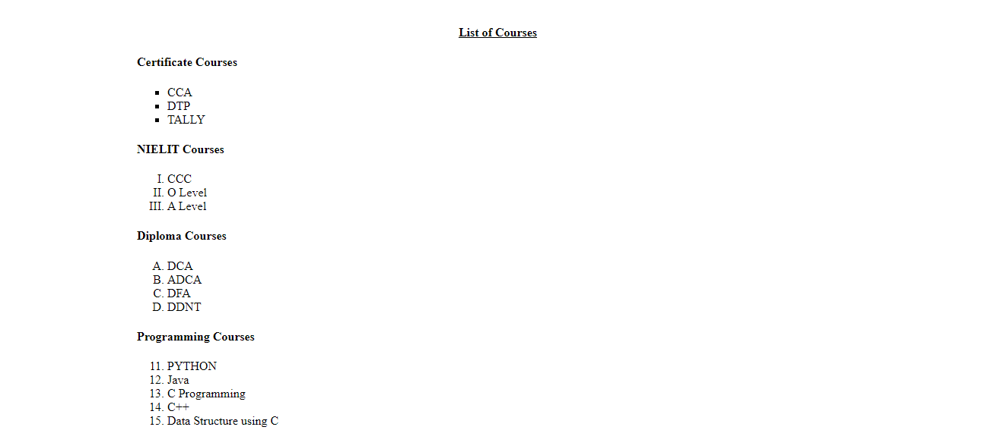

**Q3) Working with tables:** Design a HTML page like the image below.

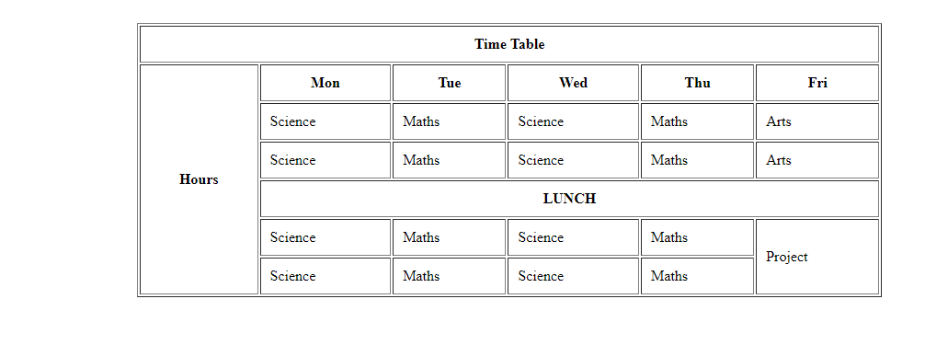

**Q4) Design a web page to play video and audio files.**

**Q5) Working with forms & GUI.**

Design a HTML page like the image below.

